Elements of Epic Poetry – Epic Hero Cycle
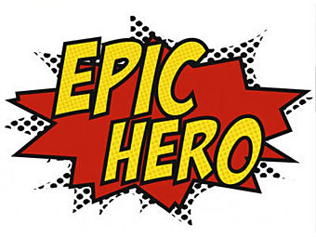

Directions: Fill out the right side of the chart with the corresponding information from Beowulf that follows the cycle of an epic hero.
.
The main character is a hero, who is often possessed of supernatural abilities or qualities.

The hero is charged with a quest.

The hero is tested, often to prove the worthiness of himself and his quest.

The presence of numerous mythical beings, magical and helpful animals, and human helpers and companions exists.

The hero’s travels take him to a supernatural world, often one that normal human beings are barred from entering.

The cycle must reach a low point where the hero nearly gives up his quest or appears defeated.

A resurrection or return to the world occurs.

Restitution. Often this takes the form of the hero regaining his rightful place on the throne.

