STMA High Ms. Vander Heiden, Room 3386
British Literature A amyvan@mystma.org
Course Syllabus 2019-2020 http://vanderheiden.weebly.com/ Google Classroom:
“‘No one else could do / What I mean to, here, no man but me / Could hope to defeat this monster. / No one could try.’”
-Beowulf

“For since I was twelve years of age, my lords, / Thanks be to God eternally alive, / husbands at the church door I’ve had five.”
–The Wife of Bath, The Canterbury Tales

Course Description. British Literature A focuses on how British literature has evolved and influenced language as a whole. This trimester, we will also be exploring the idea of self-representation. How and why do characters represent themselves? We will study analogy, Beowulf and The Canterbury Tales (Chaucer) while meeting the MN English Language Arts Standards of reading, writing, speaking, viewing, listening, media literacy, and language. There will be daily homework, projects, reading assignments, class discussions, timed essays, exams, and presentations.

Course Schedule
Trimester
Unit 1: How has English evolved?
- Assessments: Analogy of Introduction, Evolution of Language Essay

Unit 2: Beowulf
- Texts/Authors: Anglo-Saxon culture, Beowulf
- Assessments: Group Presentation, Exam, Timed Essay, Text Transformations

Unit 3: The Canterbury Tales by Geoffrey Chaucer
- Texts/Authors: “The General Prologue,” “The Wife of Bath’s Tale,” “The Pardoner’s Tale,” “The Miller’s Tale” or “The Franklin’s Tale” (?), Patience Agbabi’s Telling Tales
- Assessments: Speech, Allegory, Exam, Tale Adaptation

Required Materials: Notebook/Binder | Folder | Writing Utensil | Assignment book | Index Cards

Daily Details
-Class Log: Each day of class, a student will record the lesson’s happenings. Students are responsible for class instruction, assignments, and time that they miss. They are expected to visit the log to catch up on missing information and assignments if they are absent. Additional instructions will be discussed in class. Completing the log appropriately and accurately is part of your participation grade.

-Vocabulary Development: Students will be responsible for writing down one new vocabulary word daily on a note card. There will be a vocabulary quiz about every other week. If students plan on being absent on a quiz day, they are expected to take the quiz the day before.

Expectations. I expect you to:
- Respect yourself, your peers, the teacher, and the classroom and its contents.
- Show honesty and integrity in all efforts.
- Be prepared and on time.
- Accept and cooperate with others.
- Set high expectations for yourself.

Classroom Consequences
- Loss of participation points
- Detention or discipline referral
- Removal from class

Attendance: Attendance is mandatory, especially because participation is a factor in your grade. When you are absent, it is your responsibility to check the class log, write on your pink slip, and to check in with the teacher before or after school or during SNAP to see what you missed. If students come to school late or leave early, they are expected to turn in/pick up any homework. Otherwise, the work will be considered late. Students not in their seats when the bell rings will be marked tardy. Three tardies warrants a referral.

Assessment and Grading
All graded projects, essays, and exams must be completed to pass the course. If an assignment is one day late, it will be graded at half credit. After one day, the assignment will be given a zero, but must still be turned in to pass the class each trimester. Major projects and essays not turned in by the due date will incur a one-letter grade deduction, with further penalty accruing as each day passes. If students are absent the day before a major due date (quiz, exam, essay, project), they are still expected to take the exam or turn in the essay/project on the scheduled day. No daily assignments can be turned in after the mid-trimester marking period, and nothing may be turned in after the final marking period of the trimester.

Grading Scale:
94-100%....A 73-76%........C
90-93%......A- 70-72%........C-
87-89%......B+ 67-69%........D+ This is a challenging class for college-bound
83-86%......B 63-66%........D students, which means that your work
80-82%......B- 60-62%........D- should reflect college-bound skills and
77-79%......C+ below 60%...F comprehension.

Plagiarism/Cheating Policy
You are to do your own work unless given specific instructions about working together or in groups on a project or assignment. Definitions: Plagiarism is using another person’s language or ideas without giving that person credit; it is considered a serious act of dishonesty that carries a heavy penalty. Cheating is the act of willfully obtaining, giving, or using information on a test or assignment that distorts the true evaluation of what a student knows or has achieved.

Consequence: Plagiarism is not tolerated. Plagiarism or cheating will result in a failed grade and additional disciplinary action if necessary. All papers must be submitted to turnitin.com on or before the due date of the paper for full credit. In addition, a turnitin.com receipt or submission number must be attached to each writing assignment (when it is turned in on the due date). Papers not submitted to the website will receive no credit.
Homework Guidelines
- Assignments must be completed on loose-leaf paper or double-spaced typed in 12-point, Times New Roman font.
- Each assignment should have the proper heading in the upper left-hand corner:

Student’s Name
Ms. Vander Heiden
Brit Lit A, Period ____
Due Date
Personal Devices: We sometimes use our devices in class for rich learning experiences. Guidelines:
- When we are NOT doing a class activity with our devices, permission from the teacher must be requested and granted before using a device in class.
- Students are expected to keep their devices on their desks when using them for a class activity. Otherwise, devices should be under students’ desks or in their assigned pocket.
- Students may only use AirPods and headphones during specified work time.
- The misuse of devices (personal use, cheating) results in a discipline referral.

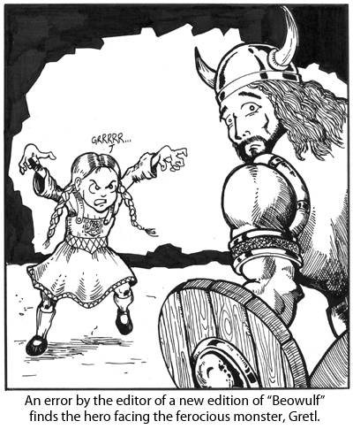

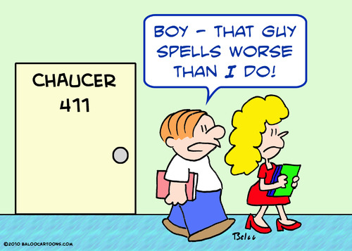

I have read and I understand the above syllabus, including expectations, consequences, and policies.

Student’s Name ___________________________________

Student’s Signature_________________________________________ Date _______________
Comments:

Name___________________ Hour_____
Brit LitA Survey
- What words, people, or places come to mind when you think of “British Literature”? (List as many as you can.)

- Why did you choose to take British Literature?

- What is your favorite piece of literature?

- What is your favorite class you’ve taken in high school?

- In what extracurricular activities do you participate?

- What are your post-high school plans?

- What is the best thing you did over the summer?

- Set two goals for yourself for this trimester. What do you hope to learn and/or achieve?
a.

b.

